**D1- evaluate the impact of evolving output mediums on the design and creation of graphic images**

For D1, you will research the ongoing changes in, and additions to, output media and the effect this has on the creation of graphic images.

***Output medium*:** printer; computer monitor; other e.g. mobile phone, PDA, plotter

**Printer**

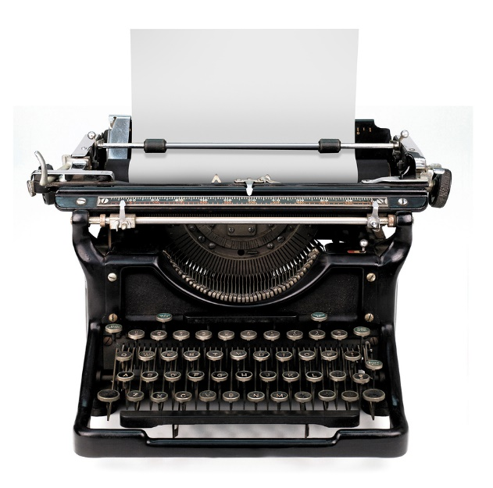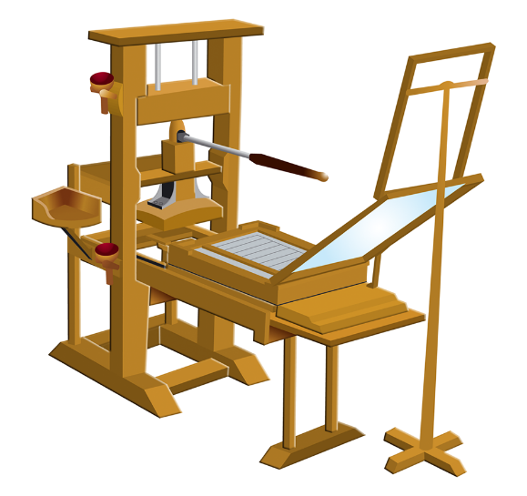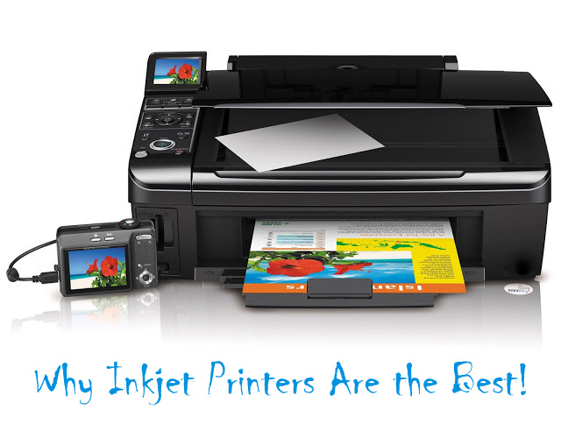Printing has been out for a long time and when we see ourselves printing out documents, it is easy. However, back in the 19th century, it was not that easy. It was introduced and it did not sound important as it does now. Back in the late 19s, paper was used to draw or write something on. They never used the computer to print out documents. Printing before used to be expensive as it was not well known. People never used to printer. However, modern days, because it has got so well known of a lot people printing and technology evolving day by day, people are using it more and more and it has become cheap to use. It was newly introduced, they did not know how to use it. Now modern day’s printing out printer is vital to do variety types of printing to do e.g. coursework, office duties. Inkjet printing was introduced in 1957 and before that printing was different. Before Inkjet printing, typewriting was introduced. They was no monitor, they was a keyboard and a paper. All the user does is type what he wants to do. He can use the ‘backspace’ to remove letters he does not want. Remember, they was no picture to print out. Typewriter can only type and do nothing else. People used to use the typewriter to type letters to their siblings/family. This was common in the 1860s and it became popular. Johann Gutenberg was the first person to innovate the printing system. He was a professional silversmith and he was the one that made the first printer. Figure 1.1 demonstrates how the first printer invented looked like. It holds a complex structure, which even I cannot figure out how it would work. As time moved on, more and more inventions came into play. They are a number of printing ways that came into play such as:

* Photocopying
* 3D Printing
* Laser Printing
* Thermal printing

This was important for graphic designers as they needed a printer to enable them to do their work. Over the year’s quality printer have come into play for it to work. Printer can print out HD quality pictures and it is important for them. As new modern printer has evolved, it is harder for them to print out.

**Mobile Phone**

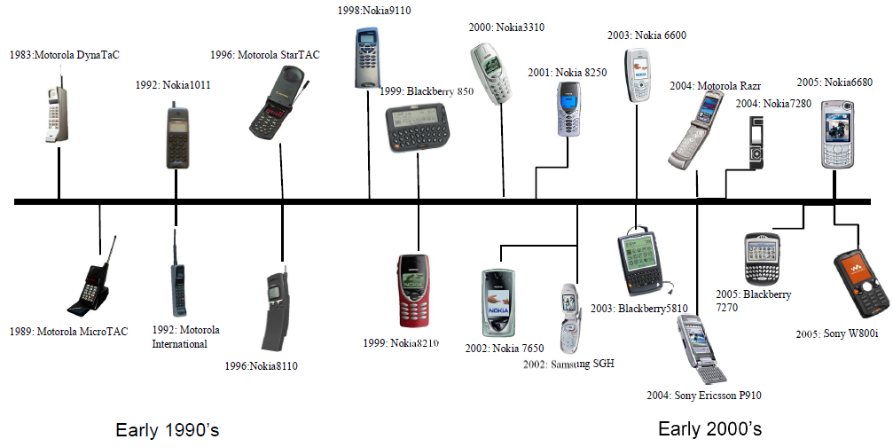Mobile phones have changed drastically over the years. The first phone that was invented in 1844 by Alexander Graham Bell and it enabled communication between two people. Before the mobile phone was invented, letters were common. People had to write letters to another person to enable communication between each other. This could create many problems, which is why the mobile phone has been successful. The timeline shows the mobile phone development history.

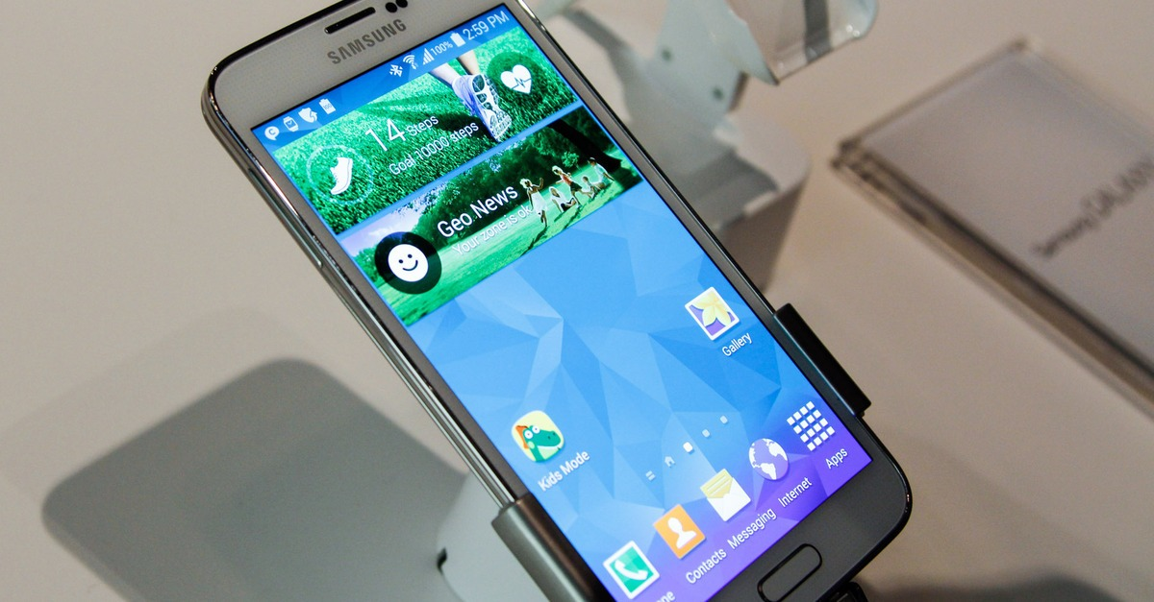As time went on, new features included and new brands came into play for it to be competitive. The latest phones have technology that was not even heard off in the 19th century. They are number of features such as controlling a TV through a user’s smartphone; fingerprint scanning; ‘facetime’, you can visualise and communicate with another person at the same time through your phone. Nokia used to dominate the latest century, but mobile phone is important for graphic designers. If they did not have their camera, they can use their phone. The timeline only shows the early 2000s. However, they are not the latest phones. It is important as they are features that allows the user to complete their work on their phone. For example, editing images; multiple resolutions and many more features. As for any technology, mobile phones have become expensive. New phones are expensive to use because they are newly released with new features. Nowadays, it is portable – you can use it without the wire. As any phone, you can use it to communicate with another person. For emergencies, you can call the police and ambulance straight away. Not only communication, you can educate yourself by using your phone e.g. maths apps; calculator.